1.

> df=read.csv(file.choose())

> n=length(df$IPG2211A2N);n [1] 397

> plot.ts(df$IPG2211A2N,ylab="Electric Production",main="Monthly Electricity Production")

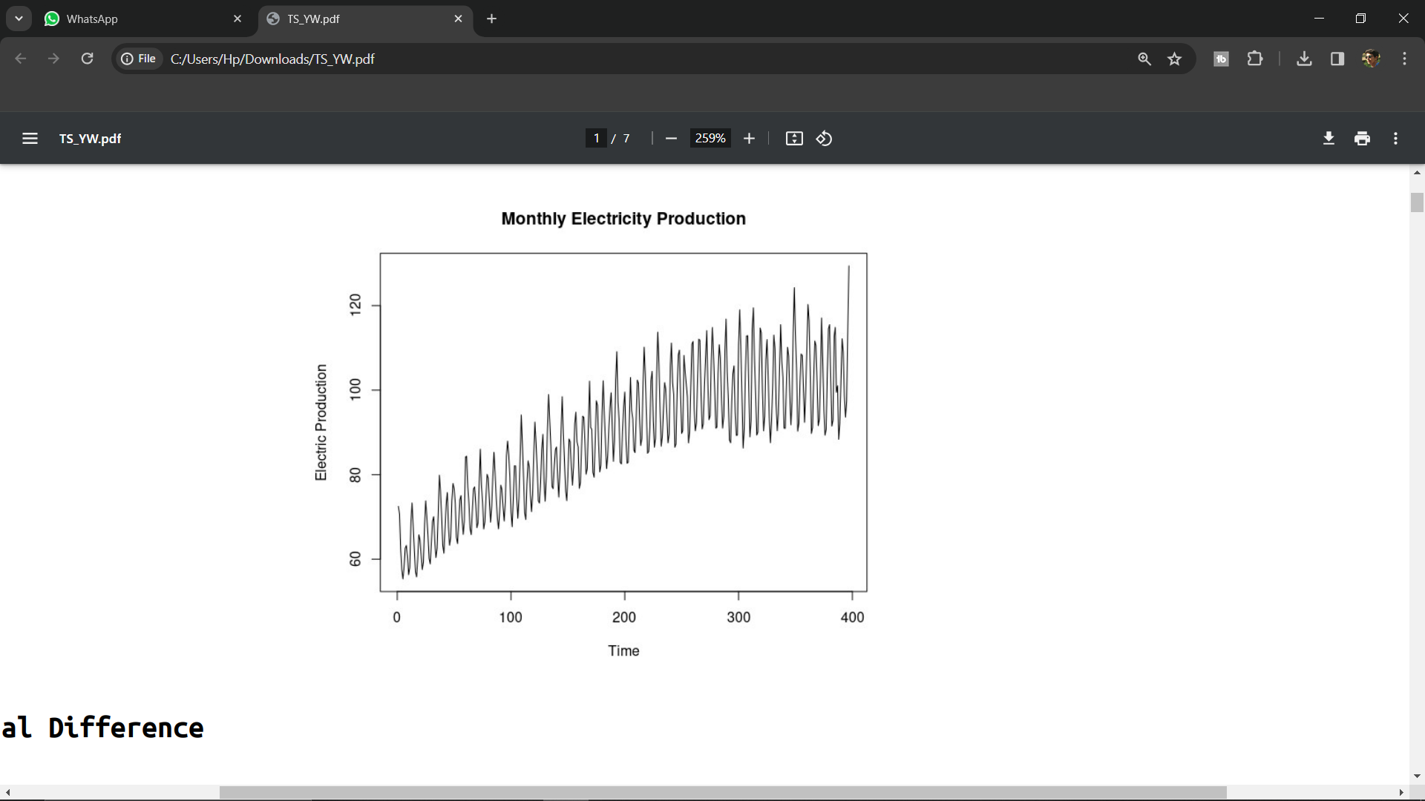

Seasonal Difference:

> v=var(Xt);v

[1] 236.7854

> yt=diff(Xt,lag=12)

> v1=var(yt);v1

[1] 11.76307

> yt2=diff(yt,lag=12)

> v2=var(yt2);v2

[1] 29.46542

Trend Difference:

> v1=var(yt);v1

[1] 11.76307

> y1=diff(yt)

> v2=var(y1);v2

[1] 10.95944

> y2=diff(y1)

> v3=var(y2):v3

[1] 26.11361

> acf(y1,lag.max=40) # 2sqrt(n)=24

> pacf(y1,lag.max=40)

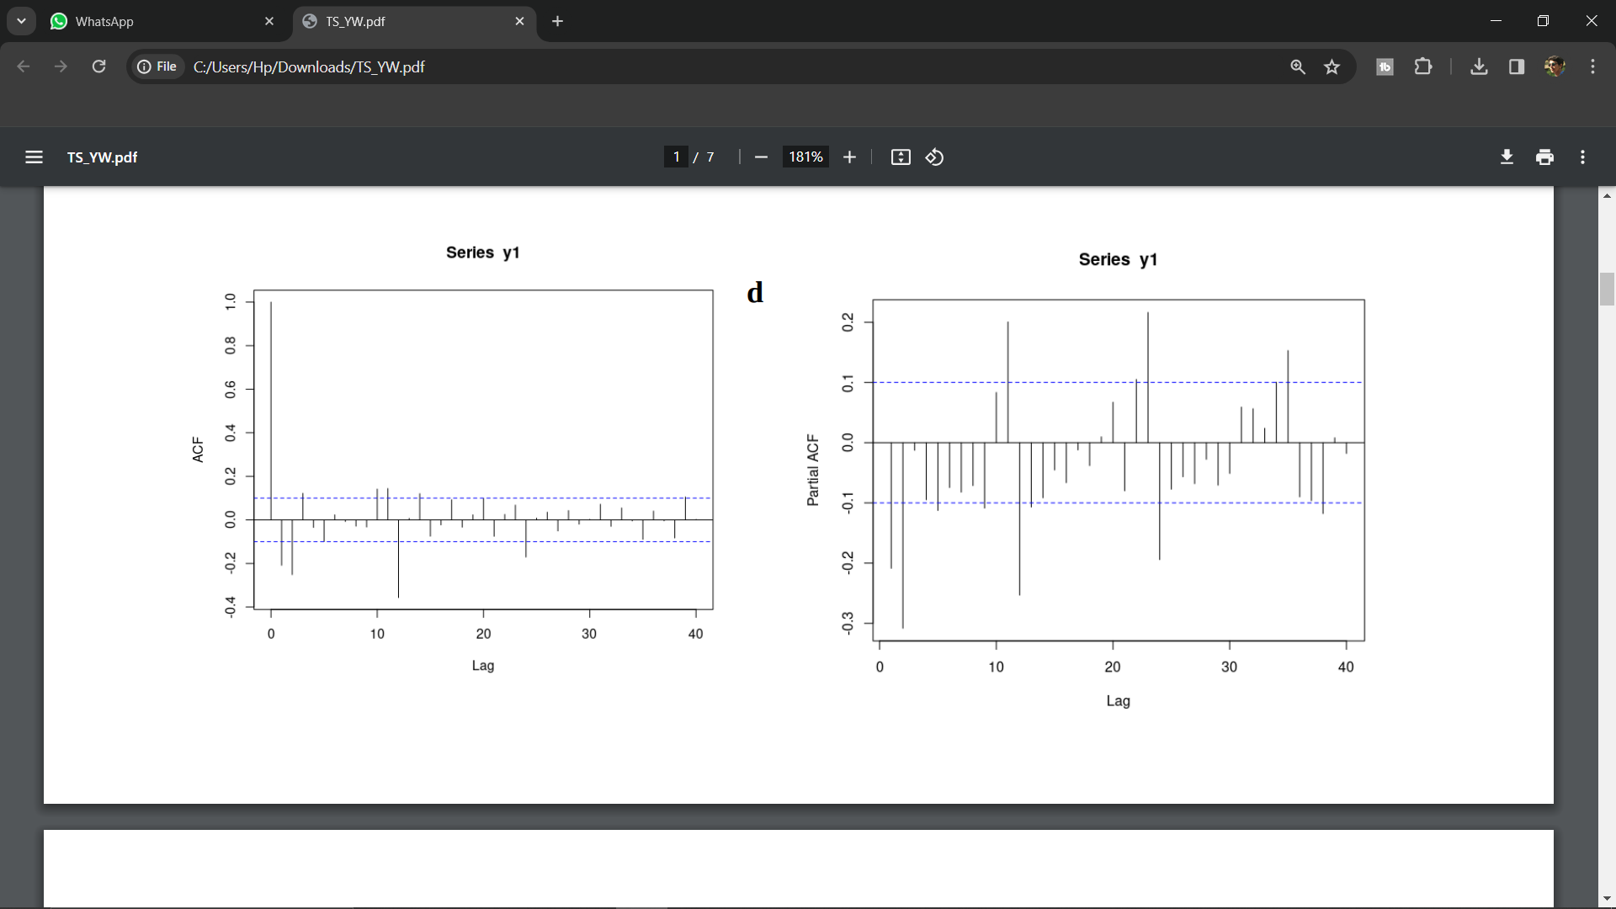

> Df=data.frame(

+ p=numeric(),

+ d=numeric(),

+ q=numeric(),

+ P=numeric(),

+ D=numeric(),

+ Q=numeric(),

+ AIC=numeric(),

+ Ljung_pvalue=numeric()

+ )

> p=1

> q=1

> d=1

> for(i in 1:2){

+ for(j in 1:2){

+ for(k in 1:2){

+

model=arima(Xt,order=c(p,d,q),seasonal=list(order=c(i,j,k),period=12,method="CSS",hessian=FALSE))

+ aic1=model$aic

+ residuals=resid(model)

+ result=Box.test(residuals,lag=24,type="Ljung-Box",fitdf=(p+q))

+ Df=rbind(Df,c(p,d,q,i,j,k,aic1,result$p.value))

+ }

+ }

+ }

> colnames(Df)=c("p","d","q","P","D","Q","AIC","Ljung_Pvalue")

> print(Df)

p d q P D Q AIC Ljung_Pvalue

1 1 1 1 1 1 1 1787.226 2.567233e-03

2 1 1 1 1 1 2 1785.329 1.306633e-02

3 1 1 1 1 2 1 1881.790 1.387547e-10

4 1 1 1 1 2 2 1794.586 1.632148e-02

5 1 1 1 2 1 1 1773.643 9.346528e-02

6 1 1 1 2 1 2 1770.670 1.365475e-01

7 1 1 1 2 2 1 1832.470 3.859641e-03

8 1 1 1 2 2 2 1787.439 1.712291e-01

> d=1

> D=1

> p=1

> P=2

> q=1

> Q=2

> model1=arima(Xt,order=c(p,d,q),seasonal=list(order=c(P,D,Q),period=12));model1

Call:

arima(x = Xt, order = c(p, d, q), seasonal = list(order = c(P, D, Q), period = 12))

Coefficients:

ar1 ma1 sar1 sar2 sma1 sma2

0.4963 -0.9502 0.5627 -0.3019 -1.3081 0.5366

s.e. 0.0518 0.0181 0.2064 0.0679 0.2086 0.1689

sigma^2 estimated as 5.45: log likelihood = -878.33, aic = 1770.67

> aic1=model1$aic;aic1

[1] 1770.67

> # Residual Analysis

> residual=model1$residuals

> acf(residual,lag.max=24)

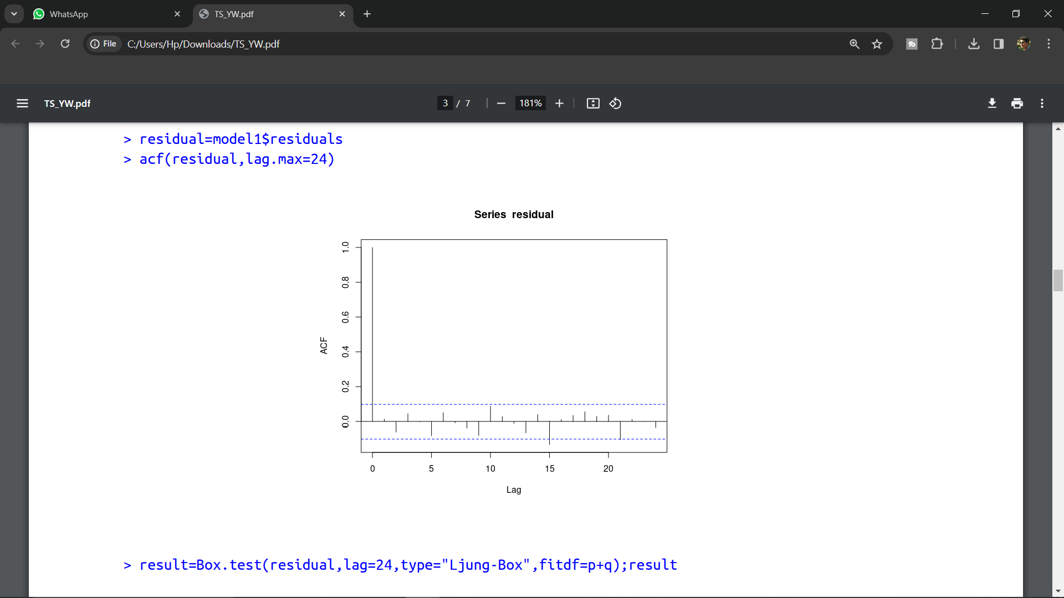

> result=Box.test(residual,lag=24,type="Ljung-Box",fitdf=p+q);result

Box-Ljung test

data: residual

X-squared = 29.298, df = 22, p-value = 0.1365

**Yuler Walker Equation ( AR(3) Model ):**

> acf_values=acf(y1, lag.max = 40, plot = FALSE)

> r=acf_values$acf

> rho=matrix(c(r[2],r[3],r[4]),3,1,byrow=TRUE);rho

[,1]

[1,] -0.2086338

[2,] -0.2513103

[3,] 0.1219564

> R=matrix(c(1,r[2],r[3],r[2],1,r[2],r[3],r[2],1),3,3,byrow=TRUE);R

[,1] [,2] [,3]

[1,] 1.0000000 -0.2086338 -0.2513103

[2,] -0.2086338 1.0000000 -0.2086338

[3,] -0.2513103 -0.2086338 1.0000000

> B=solve(R)%*%rho;B

[,1]

[1,] -0.27684620

[2,] -0.31170925

[3,] -0.01265101

> ar_model_yw=ar(y1,aic = FALSE, order.max = 3,method = "yule-walker",);ar_model_yw

Call:

ar(x = y1, aic = FALSE, order.max = 3, method = "yule-walker")

Coefficients:

1 2 3

-0.2768 -0.3117 -0.0127

Order selected 3 sigma^2 estimated as 9.56

> residuals=ar_model_yw$resid

> # Residual Analysis

> result=Box.test(residuals,lag=24,type="Ljung-Box",fitdf=3);result

Box-Ljung test

data: residuals

X-squared = 91.889, df = 21, p-value = 7.605e-11

2.

> df=read.csv(file.choose());df

> n=length(df$Monthly.beer.production);n

[1] 476

> plot.ts(df$Monthly.beer.production,ylab="Beer Production",main="Monthly Beer Production")

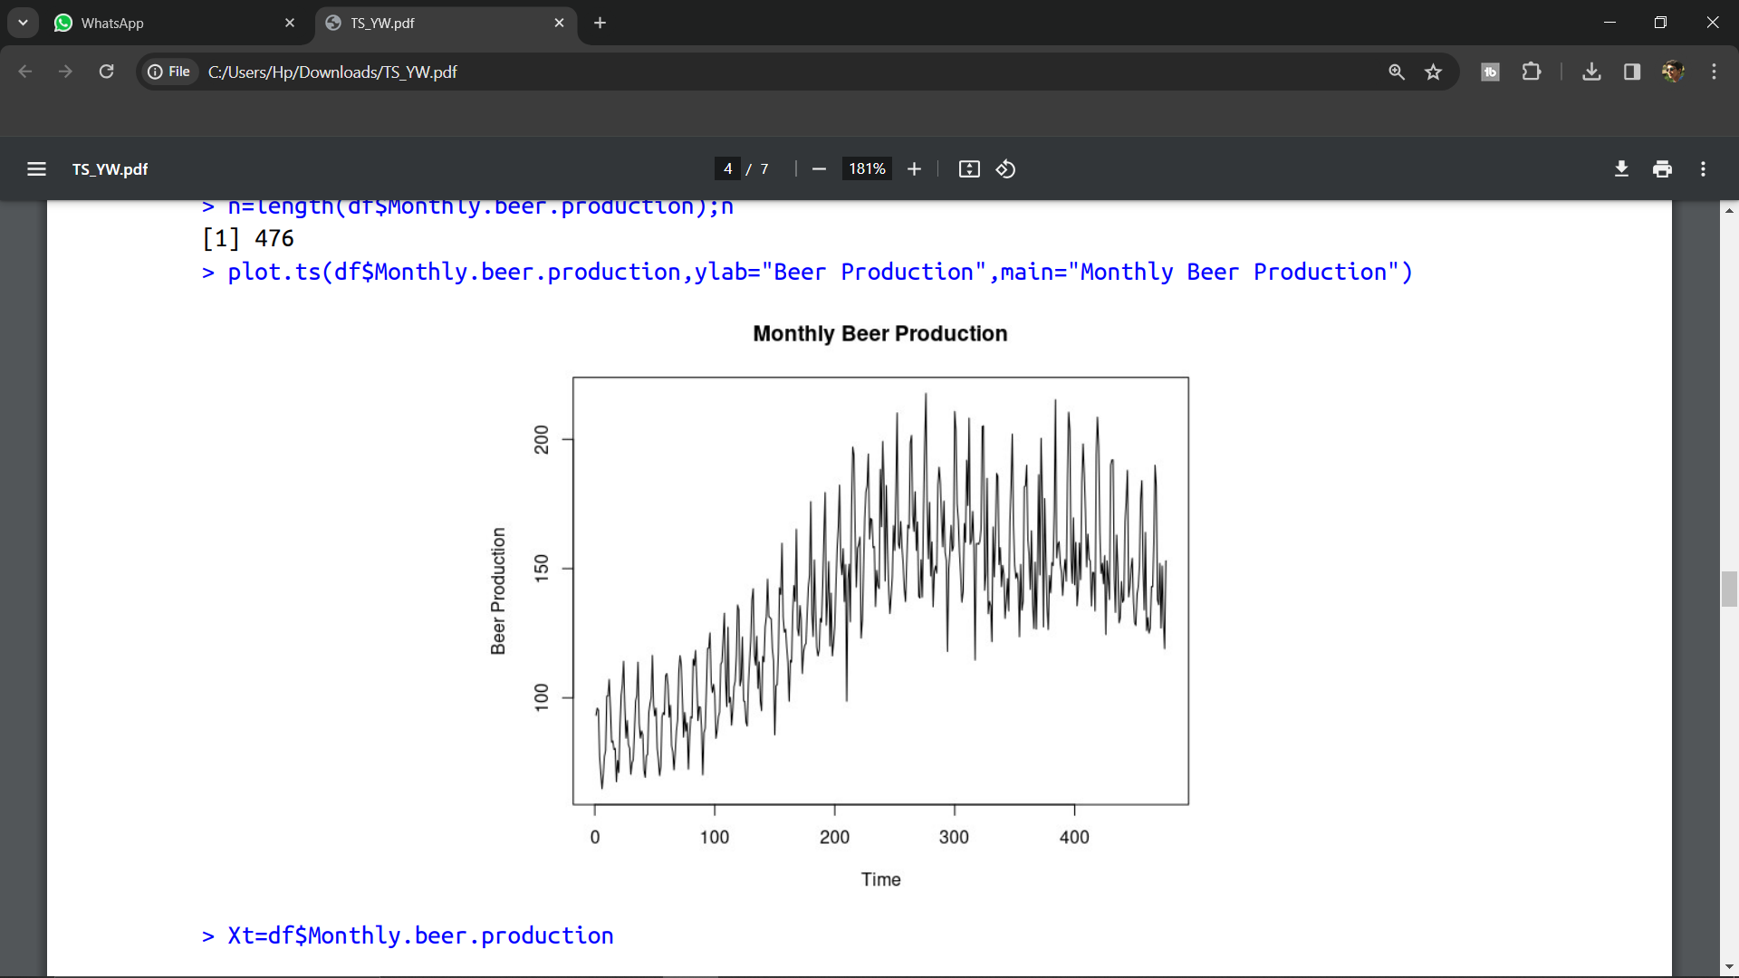

> Xt=df$Monthly.beer.production

Seasonal Difference:

> v=var(Xt);v

[1] 1138.302

> yt=diff(Xt,lag=12)

> v1=var(yt);v1

[1] 154.3948

> yt2=diff(yt,lag=12)

> v2=var(yt2);v2

[1] 403.639

Trend Difference:

> v1=var(yt);v1

[1] 154.3948

> y1=diff(yt)

> v2=var(y1);v2

[1] 337.6726

> acf(yt,lag.max=44) # 2sqrt(n)=24

> pacf(yt,lag.max=44)

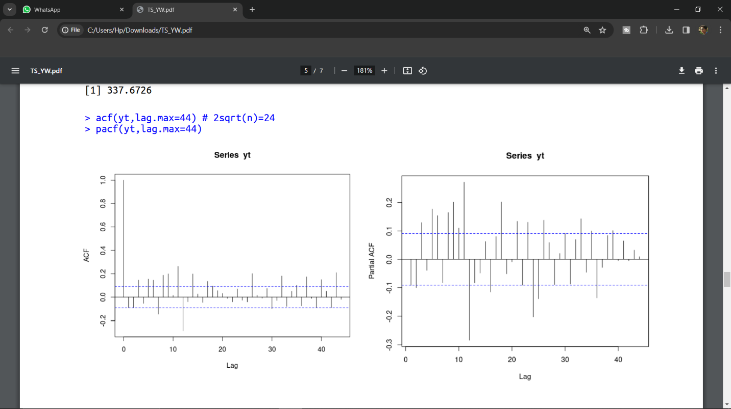

> Df=data.frame(

+ p=numeric(),

+ d=numeric(),

+ q=numeric(),

+ P=numeric(),

+ D=numeric(),

+ Q=numeric(),

+ AIC=numeric(),

+ Ljung_pvalue=numeric()

+ )

> p=2

> q=2

> d=1

> for(i in 1:2){

+ for(j in 1:2){

+ for(k in 1:2){

+ model=arima(Xt,order=c(p,d,q),seasonal=list(order=c(i,j,k),period=12,method="CSS",hessian=FALSE))

+ aic1=model$aic

+ residuals=resid(model)

+ result=Box.test(residuals,lag=44,type="Ljung-Box",fitdf=(p+q))

+ Df=rbind(Df,c(p,d,q,i,j,k,aic1,result$p.value))

+ }

+ }

+ }

> colnames(Df)=c("p","d","q","P","D","Q","AIC","Ljung_Pvalue")

> print(Df)

p d q P D Q AIC Ljung_Pvalue

1 2 1 2 1 1 1 3445.058 1.110223e-16

2 2 1 2 1 1 2 3446.545 4.440892e-16

3 2 1 2 1 2 1 3533.369 0.000000e+00

4 2 1 2 1 2 2 3448.505 1.110223e-16

5 2 1 2 2 1 1 3445.641 2.553513e-15

6 2 1 2 2 1 2 3447.782 4.440892e-16

7 2 1 2 2 2 1 3506.473 0.000000e+00

8 2 1 2 2 2 2 3449.255 1.665335e-15

> d=1

> D=1

> p=2

> P=1

> q=2

> Q=1

> model1=arima(Xt,order=c(p,d,q),seasonal=list(order=c(P,D,Q),period=12));model1

Call:

arima(x = Xt, order = c(p, d, q), seasonal = list(order = c(P, D, Q), period = 12))

Coefficients:

ar1 ar2 ma1 ma2 sar1 sma1

-0.6844 -0.3024 -0.3693 -0.424 0.1146 -0.8567

s.e. 0.1122 0.0475 0.1123 0.101 0.0571 0.0324

sigma^2 estimated as 93.54: log likelihood = -1715.53, aic = 3445.06

> aic1=model1$aic;aic1

[1] 3445.058

> residual=model1$residuals

> acf(residual,lag.max=24)

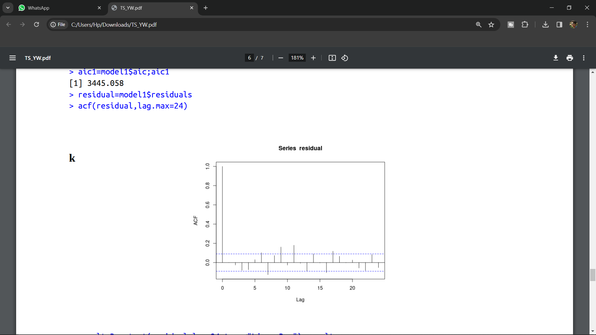

> result=Box.test(residual,lag=24,type="Ljung-Box");result

Box-Ljung test

data: residual

X-squared = 83.926, df = 24, p-value = 1.424e-08

Yuler Walker Equation ( AR(2) Model )

> acf_values=acf(yt, lag.max = 40, plot = FALSE)

> r=acf_values$acf

> rho=matrix(c(r[2],r[3]),2,1,byrow=TRUE);rho

[,1]

[1,] -0.09167538

[2,] -0.09068540

> R=matrix(c(1,r[2],r[2],1),2,2,byrow=TRUE);R

[,1] [,2]

[1,] 1.00000000 -0.09167538

[2,] -0.09167538 1.00000000

> B=solve(R)%*%rho;B

[,1]

[1,] -0.10083647

[2,] -0.09992962

> ar_model_yw=ar(Xt1,aic = FALSE, order.max = 2,method = "yule-walker",);ar_model_yw

Call:

ar(x = Xt1, aic = FALSE, order.max = 2, method = "yule-walker")

Coefficients:

1 2

-0.1008 -0.0999

Order selected 2 sigma^2 estimated as 152.2

> residuals=ar_model_yw$resid

> # Residual Analysis

> result=Box.test(residuals,lag=40,type="Ljung-Box",fitdf=2);result

Box-Ljung test

data: residuals

X-squared = 271.82, df = 38, p-value < 2.2e-16